**Experiment no:3 Date:09-03-2023**

**Aim:** Familiarization with Linux command.

**CO2:** Perform system administration tasks.

**Procedure:**

1. pwd: To print the working directory.

**.** print the path of the working directory.

$pwd

**Output Screenshot**



1. ls: Used to list the files and contents

$ls

**Output Screenshot**



1. ls -R: This will list all the subdirectories

$ls -R

**Output Screenshot**

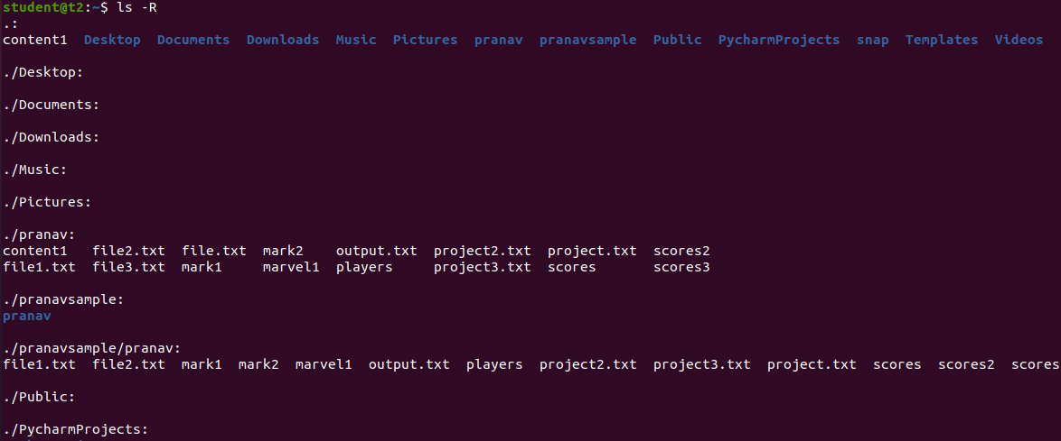

1. ls -l: long listing,

$ls -l

**Output Screenshot**

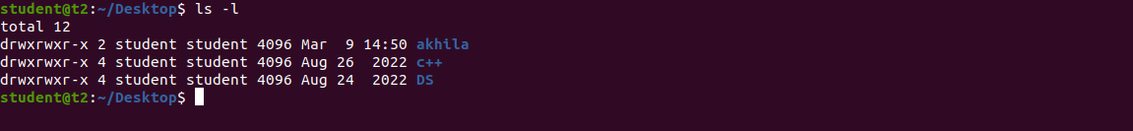

1. ls -a: To view the hidden files.

$ls -a

**Output Screenshot**

C:\Users\user\AppData\Local\Microsoft\Windows\INetCache\Content.Word\ls-a6.png

1. ls -al: To list the files and directories with detailed information including hidden files.

$ls -al

**Output Screenshot**

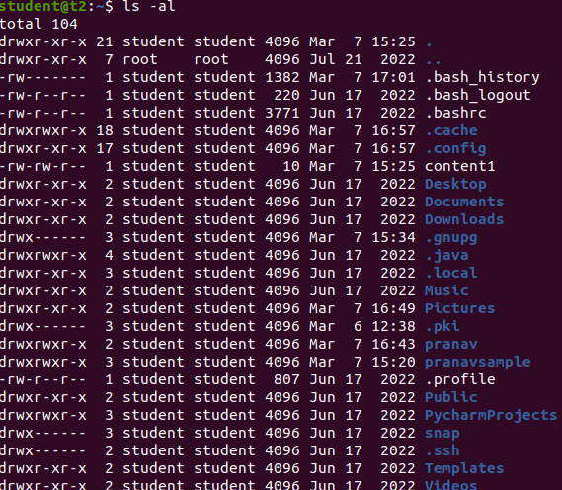

1. ls -t: To list the files in sorted in the order of last modified.

$ ls -t

**Output Screenshot**

C:\Users\user\AppData\Local\Microsoft\Windows\INetCache\Content.Word\ls-t7.png

1. ls -r: To reverse the actual sorting order.

$ls -r

**Output Screenshot**

C:\Users\user\AppData\Local\Microsoft\Windows\INetCache\Content.Word\ls-r8.png

1. mkdir: To make the directory

$mkdir [filename]

**Output Screenshot**

C:\Users\user\AppData\Local\Microsoft\Windows\INetCache\Content.Word\mkdir9.png

1. cd: To navigate through the directory.

$cd [filename]

**Output Screenshot**

C:\Users\user\AppData\Local\Microsoft\Windows\INetCache\Content.Word\10 cd anna.png

1. cd -- / cd ..: To go to the previous directory.

$cd ..

**Output Screenshot**

C:\Users\user\AppData\Local\Microsoft\Windows\INetCache\Content.Word\10 cd anna.png

1. history:

To view the history and the commands which you have been executed for certain period of time.

$history

**Output Screenshot**

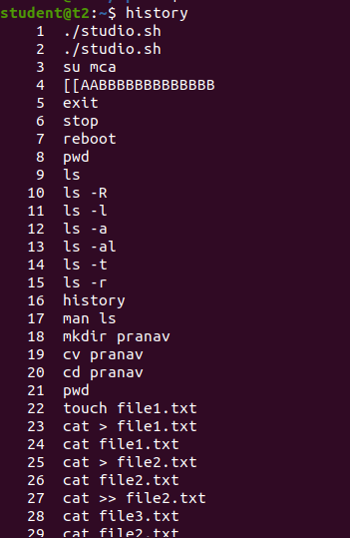

1. man: We can learn and understand about the shell using man command.

$man ls

**Output Screenshot**

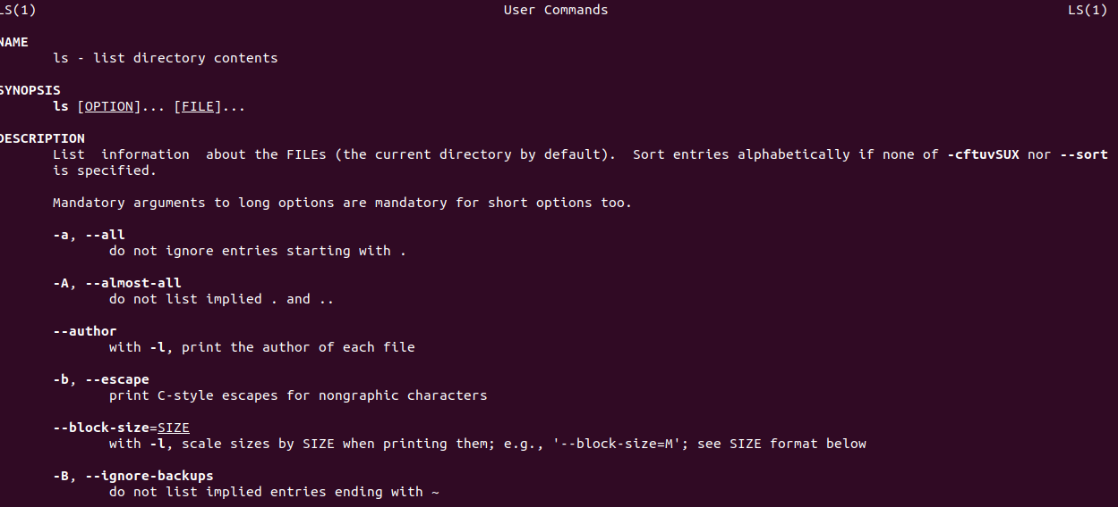

1. cat: To create file.
2. $cat > [filename]

**Output Screenshot**

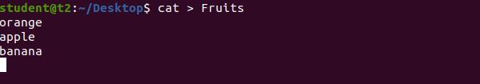

1. cat [filename]: To display the file contents.

$ cat file

**Output Screenshot**

1. cat >> [filename]: To append the file.

$cat >> file

**Output Screenshot**

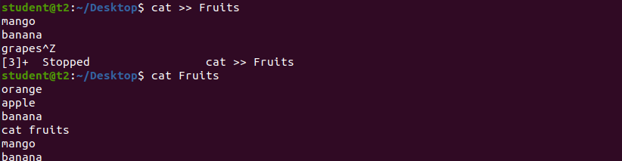

1. cat -n [filename]: To display the line number.

$cat -n file

**Output Screenshot**

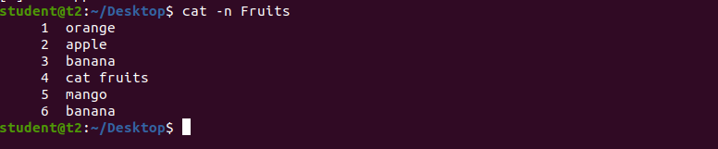

1. cat -b [filename]: To remove numbering from empty line.

$cat -b Fruits

**Output Screenshot**

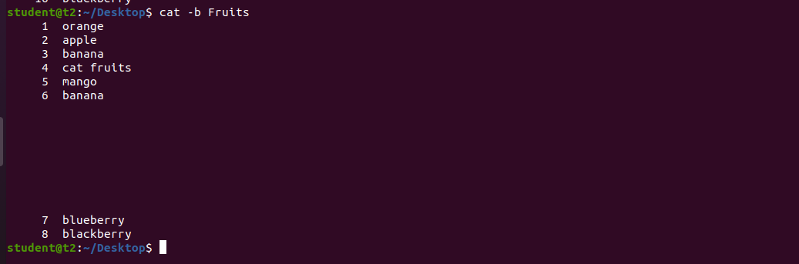

**Experiment no:4 Date:10-03-2023**

**Aim:** Familiarization with Linux command.

**CO2:** Perform system administration tasks.

1. i. cut -c[filename]: To cut by character,for cutting out sections from each line of file and writting the result to standard output.

$ cut -c 1 myFiles

**Output Screenshot**

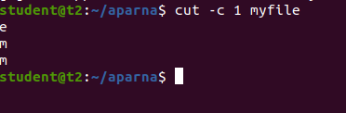

ii. cut -b :To cut by byte position

$ cut -b 2 myFiles

**Output Screenshot**

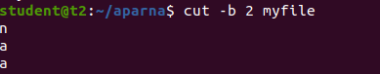

iii. cut -d : To cut by delimiter

$ cut -d - -f1 myFiles

**Output Screenshot**

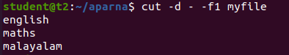

iv. $ cut -d - -f2 Files

**Output Screenshot**

v. cut - complement : Cut by complement pattern

$ cut - - complement -c 1 Files

**Output Screenshot**

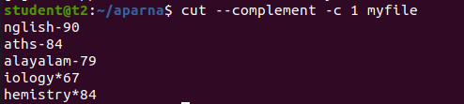

1. paste : Paste command is used to join files consist of lines from each file horizontally outputing lines.

i. $ paste Files > Document

**Output Screenshot**

ii.$ paste -d ‘%’ mk1 mk2 >mk3

$ cat mk3

**Output Screenshot**

